 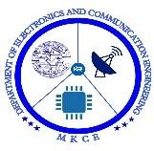 

**VOICE CONTROLLED CAR USING ARDUINO UNO**

**FOR HANDICAPPED PERSONS**

#### **A MINOR PROJECT-** **I REPORT**

***Submitted by***

|  |  |
| --- | --- |
| **BALAJI N** | **927621BEC022** |
| **SETHU PRIAN V M** | **927621BEC193** |
| **THARUN KUMAR R B** | **927621BEC229** |
| **SRIHARI M** | **927621BEC211** |

### **BACHELOR OF ENGINEERING**

in

### **­DEPARTMENTOF ELECTRONICS AND COMMUNICATION**

**ENGINEERING**

**M.KUMARASAMY COLLEGE OF ENGINEERING**

(Autonomous)

### **KARUR – 639 113**

**APRIL 2023**

**M.KUMARASAMY COLLEGE OF ENGINEERING,**

**KARUR**

**BONAFIDE CERTIFICATE**

Certified that this **18ECP103/104L-Minor project- II** report **“VOICE CONTROLLED CAR USING ARDUINO UNO FOR HANDICAPPED PERSONS”** is the bonafide work of **“BALAJI N (21BEC022), SETHUPRIAN V M(21BEC193),SRIHARI M (21BEC211),THARUN KUMAR R B (21BEC229)”** who carried out the project work under my supervision in the academic year **2021-2025 EVEN**.

|  |  |
| --- | --- |
| **SIGNATURE**  **Dr.S.PALANIVEL RAJAN, M.E., M.B.A.,**  **Ph.D.,D.LITT(USA).,**  **HEAD OF THE DEPARTMENT,**  professor,  Department of Electronics and  Communication Engineering,  M.Kumarasamy College of Engineering,  Thalavapalayam,  Karur-639113. | **SIGNATURE**  **Mr.M.G.RAJENDRAKUMAR,M.E**    **SUPERVISOR**  Assistant professor,  Department of Electronics and Communication Engineering,  M.Kumarasamy College of Engineering,  Thalavapalayam,  Karur-639113. |

This Minor project-I report has been submitted for the **18ECP104L – Minor Project- II**

Review held at M.Kumarasamy College of Engineering, Karur on _________

**PROJECT COORDINATOR**

# INSTITUTION VISION AND MISSION

**Vision**

To emerge as a leader among the top institutions in the field of technical education

#### **Mission**

**M1:** Produce smart technocrats with empirical knowledge who can surmount the global challenges

**M2:** Create a diverse, fully engaged, learner-centric campus environment to provide quality education to the students

**M3:** Maintain mutually beneficial partnerships with our alumni, industry, and Professional associations Vision of the Department

# DEPARTMENT VISION, MISSION, PEO, PO AND PSO

#### **Vision**

To empower the Electronics and Communication Engineering students with emerging technologies, professionalism, innovative research, and social responsibility.

#### **Mission**

**M1:** Attain the academic excellence through innovative teaching learning process, research areas & laboratories and Consultancy projects.

**M2:** Inculcate the students in problem solving and lifelong learning ability.

**M3:** Provide entrepreneurial skills and leadership qualities.

**M4:** Render the technical knowledge and skills of faculty members.

#### **Program Educational Objectives**

**PEO1: Core Competence:** Graduates will have a successful career in academia or industry associated with Electronics and Communication Engineering.

**PEO2: Professionalism:** Graduates will provide feasible solutions for the challenging problems through comprehensive research and innovation in the allied areas of Electronics and Communication Engineering.

**PEO3: Lifelong Learning:** Graduates will contribute to the social needs through lifelong learning, practicing professional ethics and leadership quality

**Program Outcomes**

**PO 1: Engineering knowledge:** Apply the knowledge of mathematics, science, engineering fundamentals, and an engineering specialization to the solution of complex engineering problems.

**PO 2: Problem analysis:** Identify, formulate, review research literature, and analyze complex engineering problems reaching substantiated conclusions using first principles of mathematics, natural sciences, and engineering sciences.

**PO 3: Design/development of solutions:** Design solutions for complex engineering problems and design system components or processes that meet the specified needs with appropriate consideration for the public health and safety, and the cultural, societal, and environmental considerations.

**PO 4: Conduct investigations of complex problems:** Use research-based knowledge and research methods including design of experiments, analysis and interpretation of data, and synthesis of the information to provide valid conclusions.

**PO 5: Modern tool usage:** Create, select, and apply appropriate techniques, resources, and modern engineering and IT tools including prediction and modeling to complex engineering activities with an understanding of the limitations.

**PO 6: The engineer and society:** Apply reasoning informed by the contextual knowledge to assess societal, health, safety, legal and cultural issues, and the consequent responsibilities relevant to the professional engineering practice.

**PO 7: Environment and sustainability:** Understand the impact of the professional engineering solutions in societal and environmental contexts, and demonstrate the knowledge of, and need for sustainable development.

**PO 8: Ethics:** Apply ethical principles and commit to professional ethics and responsibilities and norms of the engineering practice.

**PO 9: Individual and teamwork:** Function effectively as an individual, and as a member or leader in diverse teams, and in multidisciplinary settings.

**PO 10: Communication:** Communicate effectively on complex engineering activities with the engineering community and with society at large, such as, being able to comprehend and write effective reports and design documentation, make effective presentations, and give and receive clear instructions.

**PO 11: Project management and finance:** Demonstrate knowledge and understanding of the engineering and management principles and apply these to one’s own work, as a member and leader in a team, to manage projects and in multidisciplinary environments.

**PO 12: Life-long learning:** Recognize the need for and have the preparation and ability to engage in independent and life-long learning in the broadest context of technological change.

**Program Specific Outcomes**

**PSO1:** Applying knowledge in various areas, like Electronics, Communications, Signal processing, VLSI, Embedded systems etc., in the design and implementation of Engineering application.

**PSO2:** Able to solve complex problems in Electronics and Communication Engineering with analytical and managerial skills either independently or in team using latest hardware and software tools to fulfil the industrial

|  |  |
| --- | --- |
| **Abstract** | **Matching with POs, PSOs** |
| **Voice controlled arduino car using mobile device.** | P01,PO2,PO3,PO4,PO5,PO6,PO7,PO8,PO9,PO10,PO11,  PO12,PSO1,PSO2 |

**ACKNOWLEDGEMENT**

Our sincere thanks to **Thiru.M.Kumarasamy, Chairman** and **Dr.K.Ramakrishnan, Secretary** of **M.Kumarasamy College of Engineering** for providing extraordinary infrastructure, which helped us to complete this project in time.

It is a great privilege for us to express our gratitude to **Dr.B.S.Murugan., B.Tech., M.Tech., Ph.D., Principal** for providing us right ambiance to carry out this project work.

We would like to thank **Dr.S.Palanivel Rajan, M.E., M.B.A., Ph.D., D.Litt (USA)., Professor and Head**, **Department of Electronics and Communication Engineering** for his unwavering moral support and constant encouragement towards the completion of this project work.

We offer our wholehearted thanks to our **Project Supervisor, Mr.M.G.Rajendrakumar,M.E**, Department of Electronics and Communication Engineering for his precious guidance, tremendous supervision, kind cooperation, valuable suggestions and support rendered in making our project to be successful.

We would like to thank our **Minor Project Co-ordinator**, **Dr.E.Dinesh, M.E., Ph.D., Associate Professor**, Department of Electronics and Communication Engineering for his kind cooperation and culminating in the successful completion of this project work. We are glad to thank all the Faculty Members of the Department of Electronics and Communication Engineering for extending a warm helping hand and valuable suggestions throughout the project. Words are boundless to thank our Parents and Friends for their motivation to complete this project successfully.

# ABSTRACT

This project builds a voice controlled car that can Be controlled by voice commands which reacts in accordance to The corresponding voice command. However noise and distance Handling require future development. Simple voice commands like Left, right, forward, back, stop are used to run the car. These Commands are given to Bluetooth module via an android Application. The Bluetooth module and control unit are combined To store and test the voice commands. When an instruction for the Automobile (car) is identified, a command message is sent to Arduino UNO, the Microcontroller of the car by the Bluetooth Device. This command is analyzed by the microcontroller and followed up. In the vehicle, Image processing can be utilized to Become aware of the shade and the obstacles. This work has been Limited to the ZigBee system in the short-range (100mts range), And is linked to the car over long distance via long-range modules. The car is controlled by buttons on the application or by spoken commands of the user. The movement of the car is facilitated by the two dc servo motors connected with microcontroller at the receiver side.

**TABLE OF CONTENTS**

|  |  |  |
| --- | --- | --- |
| **CHAPTER No.** | **CONTENTS** | **PAGE No.** |
|  | **Vision and Mission of the Institute and Department** | 3 |
|  | **POs, PSOs of the Department** | 5 |
|  | **Mapping of project with POs and PSOs** | 6 |
|  | **Abstract** | 7 |
|  | **List of Figures** | 9 |
|  |
|  | **Acronyms/List of Abbreviations** | 10 |
| 1 | **Introduction** |  |
| 2    3    4    5  6  7  8  9  10 | * 1. Introduction   2. Arduino uno   **Literature review**  2.1 literature review  **Bluetooth module**  3.1 HC-05 Bluetooth Module  **Motor Driver**  4.1 Motor Driver Module L298N  **Micromors**  5.1 Micromors and Grippy Wheels  5.2 Jumper Wires  **Software Description**  **Result and discussion**  **Conclusion and future work**  **Appendices**  **Reference** | 12  13  15  17  19  21  22  23  25  27  28  29 |

**LIST OF FIGURE**

|  |  |  |
| --- | --- | --- |
| **FigureNo** | **TITLE** | **Page No** |

|  |  |  |
| --- | --- | --- |
| 1.1  2.1  3.1  4.1  5.1 | Arduino UNO  HC-05 Bluetooth module  Motor driver  Connection diagram  Car module | 14  18  20  24  26 |

**LIST OF ABBREVIATIONS**

|  |  |
| --- | --- |
|  |  |
| PWM  USB  IDE  PAN  FHSS  EEPROM | Pulse Width Modulation  Universal Serial Bus  Integrated Development Environment  Permanent Account Number  Frequency Hopping Spread Spectrum  Electrically Erasable Programmable Read Only Memory |

# CHAPTER 1

# INTRODUCTION

# In this project, we will learn how to make Voice Controlled Robot Car Using Arduino. The robotic car can be controlled wirelessly via voice commands directly from the user. The robot can move forward, backward, left, and right and can also be stopped.

# This is an Arduino based, Bluetooth controlled RC car. It is controlled by a smart phone application. Bluetooth controlled car is controlled by using Android mobile phone instead of any other method like buttons, gesture etc. Here only needs to touch button in android phone to control the car in forward, backward, left and right directions. So here android phone is used as transmitting device and Bluetooth module placed in car is used as receiver. Android phone will transmit command using its in-built Bluetooth to car so that it can move in the required direction like moving forward, reverse, turning left, turning right and stop.

# 1.2 Arduino Uno

The Arduino Uno is an open-source microcontroller board based on the Microchip ATmega328P microcontroller and developed by Arduino.cc The board is equipped with sets of digital and Analog input/output (I/O) pins that may be interfaced to various expansion boards (shields) and other circuits. The board has 14 digital I/O pins (six capable of PWM output), 6 Analog I/O pins, and is programmable with the Arduino IDE (Integrated Development Environment), via a type B USB cable. It can be powered by the USB cable or by an external 9-volt battery, though it accepts voltages between 7 and 20 volts. The Uno board is the first in a series of USB-based Arduino boards; it and version 1.0 of the Arduino IDE were the reference versions of Arduino, which have now evolved to newer releases. The ATmega328 on the board comes pre-programmed with a bootloader that allows uploading new code to it without the use of an external hardware programmer. Each of the 14 digital pins and 6 analog pins on the Uno can be used as an input or output, under software control.They operate at 5 volts. Each pin can provide or receive 20 mA as the recommended operating condition and has an internal pull-up resistor (disconnected by default) of 20-50K ohm. A maximum of 40mA must not be exceeded on any I/O pin to avoid permanent damage to the microcontroller.

There are many versions of Arduino boards introduced in the market like Arduino Uno, Arduino Due, Arduino Leonardo, Arduino Mega, however, most common versions are Arduino Uno and Arduino Mega.

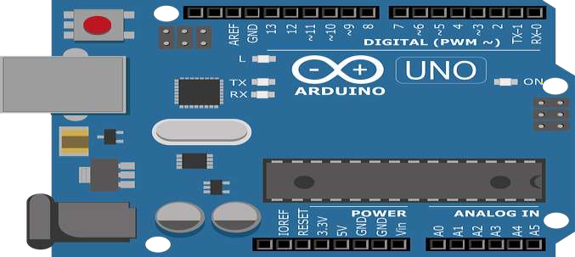

**Figure 1.1 arduino uno**

# CHAPTER 2

# 2.1 Literature review

A vehicle that is capable to drive without the assistance of a real person is often referred to as an autonomous car. Since this concept is becoming more popular each day, we chose to build an autonomous car that can be driven by a mobile app over a Bluetooth connection for autonomous car prototype with Arduino, a L298N motor driver, a DC motor, and a Bluetooth module HC-05, and controlling the car through a mobile application. Any Android device with the installed application can be used as a transmission device, while a Bluetooth module attached to the automobile serves as a receiver. With its built-in Bluetooth feature, the Android device can connect and send commands to the automobile, allowing it to travel in the desired direction, such as forward, reverse, turning left, turning right, and stopping.  In this method, a microcontroller with android devices is linked through a Bluetooth module to receive desired voice commands. The robot then escapes obstacles and detects distant objects. The android application that is used to convert a voice to a text command and then transmit data to a microcontroller moves the robot via a voice application according to the user's command. Through the software application, the user of a robotic car will choose the route or path to control the movement of the car. The user can monitor the robot's movements on his own smart device and allow the car to drive in his own way.

An android application with a microcontroller is used for required tasks. The connection between the android app and the vehicle is facilitated with Bluetooth technology. The car is controlled by buttons on the application or by spoken commands of the user. The movement of the car is facilitated by the two dc servo motors connected with microcontroller at the receiver side. At the receiver end the data gets decoded by the receiver and is fed to the microcontroller which drives the DC motors for the necessary work.

**CHAPTER 3**

# 3.1 HC-05 Bluetooth Module

HC-05 is a Bluetooth module which is designed for wireless communication. This module can be used in a master or slave configuration. It is used for many applications like wireless headset, game controllers, wireless mouse, wireless keyboard and many more consumer applications. It has range up to <100m which depends upon transmitter and receiver, atmosphere, geographic & urban conditions. It is IEEE 802.15.1 standardized protocol, through which one can build wireless Personal Area Network (PAN). It uses frequency-hopping spread spectrum (FHSS) radio technology to send data over air. It uses serial communication to communicate with devices. It communicates with microcontroller using serial port (USART).

A Bluetooth Communication Between Devices First Send data from Smartphone terminal to HC-05 Bluetooth module and see this data on PC serial terminal and vice versa. To communicate smartphone with HC-05 Bluetooth module, smartphone requires Bluetooth terminal application for transmitting and receiving data. You can find Bluetooth terminal applications for android and windows in respective app store.

Before establishing communication between two Bluetooth devices, 1st we need to pair HC-05 module to smartphone for communication. First, search for new Bluetooth device from your phone. You will find Bluetooth device with ―HC-05 name. Second, click on connect/pair device option; default pin for HC-05 is 1234 or 0000.In smart phone, open Bluetooth terminal application and connect to paired device HC-05. It is simple communicate, we just have to type in the Bluetooth terminal application of smartphone. Characters will get sent wirelessly to Bluetooth module HC-05.

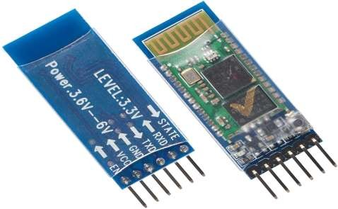

**Figure 2.2 HC-05 bluetooth module**

**CHAPTER 4**

**4.1 Motor Driver Module L298N**

This L298N Based Motor Driver Module is a high power motor driver perfect for driving DC Motors and Stepper Motors. It uses the popular L298 motor driver IC and has the onboard 5V regulator which it can supply to an external circuit. It can control up to 4 DC motors, or 2 DC motors with directional and speed control This motor driver is perfect for robotics and mechatronics projects and perfect for controlling motors from microcontrollers, switches, relays, etc. Perfect for driving DC and Stepper motors for micro mouse, line following robots, robot arms, etc. An H-Bridge is a circuit that can drive a current in either polarity and be controlled by Pulse Width Modulation (PWM).Pulse Width Modulation is a means of controlling the duration of an electronic pulse. In motors try to imagine the brush as a water wheel and electrons as the flowing droplets of water. The voltage would be the water flowing over the wheel at a constant rate, the more water flowing the higher the voltage. Motors are rated at certain voltages and can be damaged if the voltage is applied to heavily or if it is dropped quickly to slow the motor down. Thus PWM. Take the water wheel analogy and think of the water hitting it in pulses but at a constant flow. The longer the pulses the faster the wheel will turn, the shorter the pulses, the slower the water wheel will turn. Motors will last much longer and be more reliable if controlled through PWM.

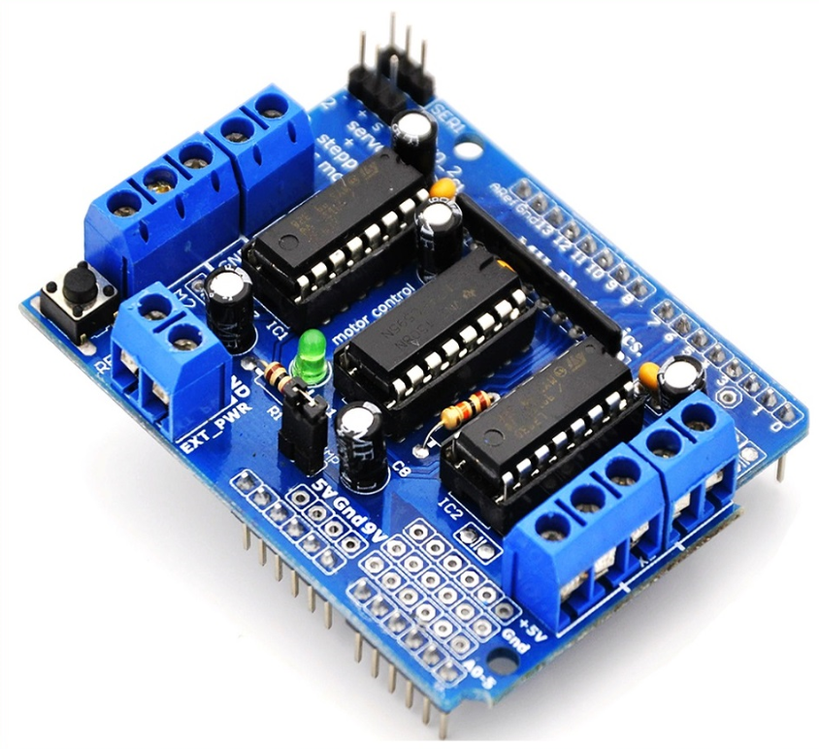

**Figure 3.1 Motor driver**

**CHAPTER 5**

# 5.1 Micromors and Grippy Wheels

Mobile wheeled or tracked robots have a minimum of two motors which are used to propel and steer the robot. Hobbyists tend to choose skid steering (like a tank) because of its simplicity to design, incorporate and control. A three wheeled robot ‘s third (rear) wheel usually prevents the robot from falling over. Four wheeled robots have either two or four drive motors and use skid steering. Six wheeled robots most commonly have either two, four or six drive motors. Individuals who use an R/C car as a basis for their robot use rack and pinion steering where one motor is connected to a drive train and the other (usually a servo motor) is used for steering. Increasing the number of drive motors helps the robot to climb steeper inclines by increasing the torque. Adding idle wheels (wheels not connected to a motor) often has the unfortunate consequence of removing weight from the drive wheels resulting in slip and loss of traction. In the image below, the center wheel, chosen mistakenly as the driven wheel, often loses contact with the ground. The way around this is to add suspension.

# 5.2 Jumper Wires

A jump wire is an electrical wire or group of them in a cable with a connector or pin at each end. Wires are used to connect components to each other on the breadboard or other prototype, internally or with other equipment or components, without soldering. Wire connectors could be male or female. A male connector is commonly referred to as a plug and has a solid pin for a center conductor. A female connector is commonly referred to as a jack and has a center conductor with a hole in it to accept the male pin.

# CHAPTER 6

# Software Description

# Arduino software is used to put the instruction of whole functions of this system to the microcontroller. Here we use programming language C for coding. The program for executing this project has been written in C language. The program is burnt in the microcontroller using burner software. The program is stored in the EEPROM of the microcontroller, which is present in the NodeMCU ESP8266. By this software we put the data and instruction for forward, backward, left, right operation of this system. In android application when we press a button, a corresponding signal is sent through the Bluetooth to Bluetooth module (HC-05) which is connected with the NodeMCUESP8266. Similarly an android application is been built for Wi-Fi module and when the buttons been pressed through the application the corresponding signal is been sent through the NodeMCUESP8266 and the motor driver drives the wireless car. When signal data arrives the NodeMCU ESP8266 the pin which corresponds to the particular input is set to high. Now that pin gives the output to the motor driver section. Motor driver switches accordingly the data bit, if the data bit is low then the corresponding pin of the motor driver doesn‘t work else high bit then the corresponding Pin of the motor driver is on. We have used Arduino IDE version 1.8.1 for writing program. There are two steps of the programming. First set up section where we define all the variables. Second loop part where the program runs continuously.

# Circuit Diagram

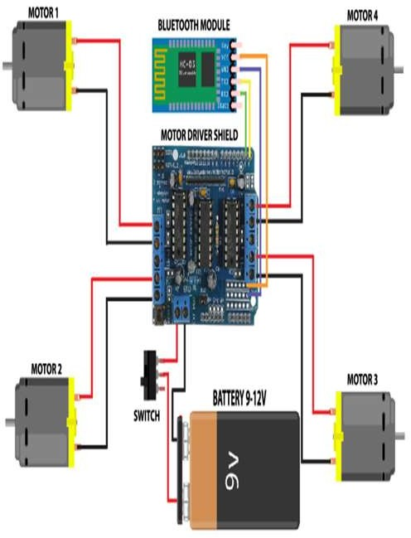

**Figure 4.1 connection diagram**

**CHAPTER 7**

**Result and discussion**

Here we work on common mode and when we want to change settings of HC-05 Bluetooth module like change password for connection, baud rate, Bluetooth device‘s name etc. To do this, HC-05 has AT commands. To use HC-05 Bluetooth module in AT command mode, connect Key pin to High (VCC). Default Baud rate of HC-05 in command mode is 38400bps. Following are some AT command generally used to change setting of Bluetooth module. To send these commands, we have to connect HC-05 Bluetooth module to the PC via serial to USB converter and transmit these command through serial terminal of PC. We have created functions for different directions of car. There are five conditions for this Bluetooth controlled car which are used to give the directions. This car is designed to be controlled by voice commands. We connect the Bluetooth module with the mobile app. We accept character by character from the serial buffer sent by the app and combine them to form a string.

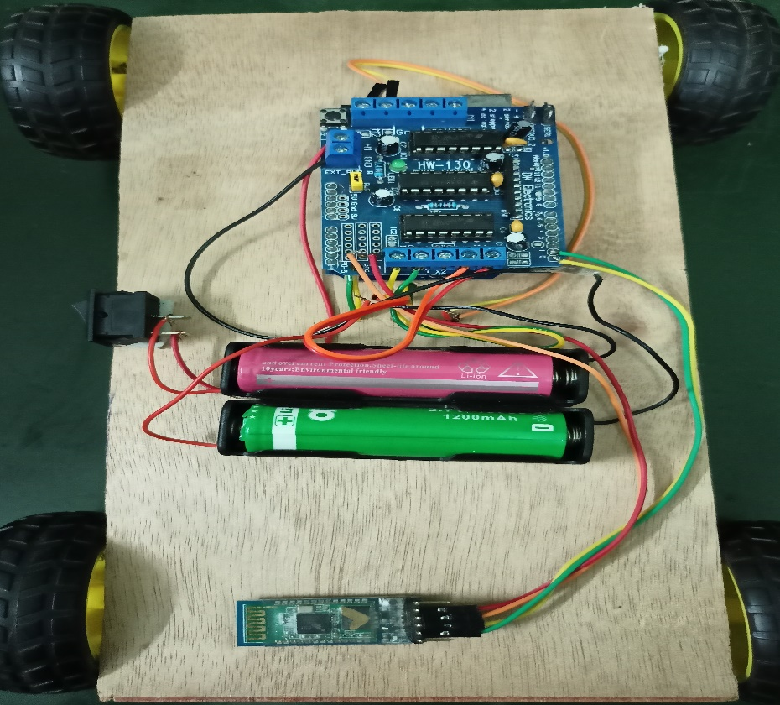

**Figure 5.1 car module**

**CHAPTER 8**

# Conclusion and future work

The project \"Voice Controlled Robotic Vehicle\" has numerous uses both now and in the future. In the future, improvements can be added to the project to make it more effective. The project has a wide range of applications, including military, home security, rescue missions, industry, and medical support. Using the given resources, we were able to create a rudimentary model of a voice-controlled robotic car. Because this project is simple to implement, this robot is advantageous to human life. The Voice Control Robot is beneficial for monitoring and assisting disabled persons. It is simple to use because it operates with basic voice commands. It is effective in locations where humans are unable to reach. This robot is modest in size. This robot can be used to spy on people. It has the potential to be utilised for surveillance. For security purposes, we can incorporate a web cam into this robot. The voice recognition software is accurate and sensitive to background noise, allowing it to distinguish a voice command.

**CHAPTER 9**

**APPENDICES**

This project was developed in a way that the robot is controlled by voice commands. An android application with a microcontroller is used for required tasks. The connection between the android app and the vehicle is facilitated with Bluetooth technology. The robot is controlled by buttons on the application or by spoken commands of the user. The movement of the robot is facilitated by the two dc servo motors connected with microcontroller at the receiver side. The commands from the application is converted in to digital signals by the Bluetooth RF transmitter for an appropriate range to the robot. At the receiver end the data gets decoded by the receiver and is fed to the microcontroller which drives the DC motors for the necessary work. The aim of Voice Controlled Robotic Vehicle is to perform the required task by listening to the commands of the user. A prior preparatory session is needed for the smooth operation the robot by the user. Voice Controlled CAR is a mobile robot whose movement can be controlled by the commander by giving specific voice commands.The speech is received by a microphone and processed by the Bluetooth module .Speech recognition is a technology where the system understands the words given through speech.

# CHAPTER 10

# References

# <https://create.arduino.cc/projecthub/Yug_Ajmera/>

# https://www.instructables.com/id/

# https://www.researchgate.net/publication/325722323_IJSRST173866_ Bluetooth_Remote_Controlled_Car_using_Arduino

# https://ieeexplore.ieee.org/document/8093565

# https://www.viralsciencecreativity.com/post/

# https://nevonprojects.com/

# https://www.hackster.io/Yug_Ajmera/

